

In the name of God,

the merciful, the compassionate

HomeWork 7  
(Observer Design)

By

*Reza Nopour*  
402126924

Advanced Automatic Control  
Mechanical Engineering Department  
Amirkabir University of Technology  
02 Jan. 24

# Problem 1 Description

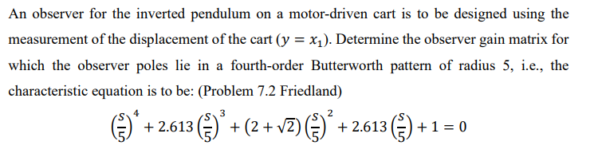

# Solution

State Space representation of this system is,

$$\dot{x}=\left[\begin{matrix}0 & 1 & 0 & 0 \\ 0 & -\frac{k^{2}}{MRr^{2}} & -\frac{mg}{M} & 0 \\ 0 & 0 & 0 & 1 \\ 0 & \frac{k^{2}}{MlRr^{2}} & \frac{M+m}{Ml}g & 0\end{matrix}\right]\left\{\begin{matrix}x \\ \dot{x} \\ θ \\ \dot{θ}\end{matrix}\right\}+\left[\begin{matrix}0 \\ \frac{k}{MRr} \\ 0 \\ -\frac{k}{MlRr}\end{matrix}\right]\left[e\right] \\ y=\left[\begin{matrix}1 & 0 & 0 & 0 \\ 0 & 0 & 1 & 0\end{matrix}\right]x+\left[\begin{matrix}0 \\ 0\end{matrix}\right]\left[e\right]$$

where,

$$m=0.1 kg, M=1.0 kg, l=0.1 m, g=9.8 m.s^{-2}, k=1 V.s, R=100 Ω, r=0.02 m$$

$$A=\left[\begin{matrix}0 & 1 & 0 & 0 \\ 0 & -25 & -0.98 & 0 \\ 0 & 0 & 0 & 1 \\ 0 & 25 & 10.78 & 0\end{matrix}\right], B=\left[\begin{matrix}0 \\ 0.5 \\ 0 \\ -0.5\end{matrix}\right]$$

First and foremost, the observability matrix should be evaluated,

$$Q=\left[\begin{matrix}C \\ CA \\ CA^{2} \\ CA^{3}\end{matrix}\right]=\left[\begin{matrix}1 & 0 & 0 & 0 \\ 0 & 1 & 0 & 0 \\ 0 & -0.25 & -0.98 & 0 \\ 0 & 625 & 24 & -0.98\end{matrix}\right]→\left|\begin{matrix}1 & 0 & 0 & 0 \\ 0 & 1 & 0 & 0 \\ 0 & -0.25 & -0.98 & 0 \\ 0 & 625 & 24 & -0.98\end{matrix}\right|=0.9604≠0$$ It is observable.

$$\left|sI-A\right|=s^{4}+25s^{3}-10.78s^{2}-245s=0 \\ →a_{0}=0 \\ a_{1}=-245 \\ a_{2}=-10.78 \\ a_{3}=25$$

New characteristics equation,

$${\left(\frac{s}{5}\right)}^{4}+2.613{\left(\frac{s}{5}\right)}^{3}+\left(2+\sqrt{2}\right){\left(\frac{s}{5}\right)}^{2}+2.613\left(\frac{s}{5}\right)+1=0 \\ s^{4}+13.065s^{3}+25\left(2+\sqrt{2}\right)s^{2}+326.625s+625=0 \\ α_{0}=625,α_{1}=326.625,α_{2}=25\left(2+\sqrt{2}\right),a_{3}=13.065$$

$$Ψ=\left|\begin{matrix}1 & 25 & -10.78 & -245 \\ 0 & 1 & 25 & -10.78 \\ 0 & 0 & 1 & 25 \\ 0 & 0 & 0 & 1\end{matrix}\right| \\ α={\left[\begin{matrix}α_{3} & α_{2} & α_{1} & α_{0}\end{matrix}\right]}^{T}, a={\left[\begin{matrix}a_{3} & a_{2} & a_{1} & a_{0}\end{matrix}\right]}^{T}$$

$$L={\left[QΨ\right]}^{-1}\left(α-a\right)={\left[\begin{matrix}-11.935 & 394.5103 & -452.0058 & -1993.6186\end{matrix}\right]}^{T}$$

# Problem 2 Description

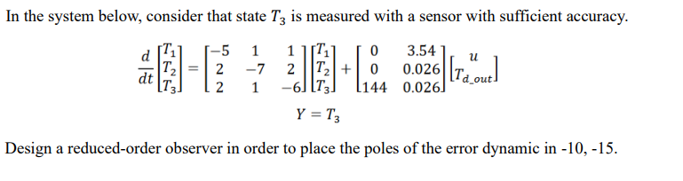

# Solution

$$\left[\begin{matrix}{\dot{T}}_{1} \\ {\dot{T}}_{2} \\ {\dot{T}}_{3}\end{matrix}\right]=\left[\begin{matrix}-5 & 1 & 1 \\ 2 & -7 & 2 \\ 2 & 1 & -6\end{matrix}\right]\left[\begin{matrix}T_{1} \\ T_{2} \\ T_{3}\end{matrix}\right]+\left[\begin{matrix}0 & 3.54 \\ 0 & 0.026 \\ 144 & 0.026\end{matrix}\right]\left[\begin{matrix}u \\ T_{d_{out}}\end{matrix}\right] \\ Y=\left[\begin{matrix}0 & 0 & 1\end{matrix}\right]\left[\begin{matrix}T_{1} \\ T_{2} \\ T_{3}\end{matrix}\right]$$

$$A_{ee}=\left[\begin{matrix}-7 & 2 \\ 1 & -5\end{matrix}\right] \\ C_{s}A_{se}=\left[\begin{matrix}1 & 2\end{matrix}\right]$$

*Checking the observability*,

$$Q=\left[\begin{matrix}C \\ CA\end{matrix}\right]=\left[\begin{matrix}\begin{matrix}1 & 2\end{matrix} \\ \begin{matrix}-5 & -8\end{matrix}\end{matrix}\right]→full rank$$

It is observable.

$$\left|sI-\left(A-LC\right)\right|$$

$$\left|\left[\begin{matrix}s & 0 \\ 0 & s\end{matrix}\right]-\left(\left[\begin{matrix}-7 & 2 \\ 1 & -5\end{matrix}\right]-\left[\begin{matrix}l_{1} \\ l_{2}\end{matrix}\right]\left[\begin{matrix}1 & 2\end{matrix}\right]\right)\right|=\left|\begin{matrix}s+7+l_{1} & 2l_{1}-2 \\ l_{2}-1 & s+5+2l_{1}\end{matrix}\right|=0 \\ s^{2}+\left(12+l_{1}+2l_{2}\right)s-\left(l_{2}-1\right)\left(2l_{1}-2\right)+\left(7+l_{1}\right)\left(5+2l_{2}\right)=0$$

Considering $s_{1}=-10,s_{2}=-15$

Therefore,

$$l_{1}=-13 \\ l_{2}=13$$

# Problem 3 Description

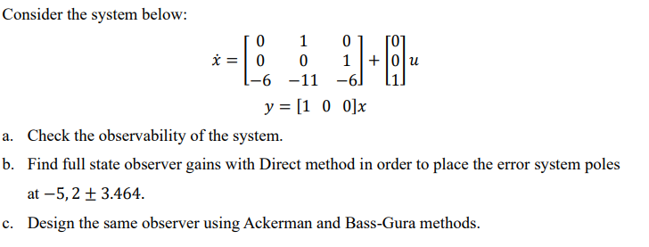

# Solution

1. The observability matrix is as follows,

$$Q=\left[\begin{matrix}C \\ CA \\ CA^{2} \\ CA^{n-1}\end{matrix}\right]=\left[\begin{matrix}1 & 0 & 0 \\ 0 & 1 & 0 \\ 0 & 0 & 1\end{matrix}\right]→\left|\begin{matrix}1 & 0 & 0 \\ 0 & 1 & 0 \\ 0 & 0 & 1\end{matrix}\right|=1≠0→full rank$$

It is observable.

1. Direct method for observer gains,

$$k={\left[\begin{matrix}k_{1} & k_{2} & k_{3}\end{matrix}\right]}^{T}$$

$$\left|sI-A+kC\right|=\left|\begin{matrix}s-k_{1} & -1 & 0 \\ k_{2} & s & -1 \\ k_{3}+6 & 1 & s+6\end{matrix}\right|=s^{3}+\left(k_{1}+6\right)s^{2}+\left(6k_{1}+k_{2}+11\right)s+6k_{2}+k_{3}+6$$

Desired poles are as follows,

$$p_{d}=\left(s+5\right)\left(s+2+3.464i\right)\left(s+2-3.464i\right)=s^{3}+9s^{2}+36s+80$$

Comparing the obtained equations,

$$k_{1}=3,k_{2}=7,k_{3}=-1$$

which demonstrates the feedback gain of the system.

$$p_{d}\left(A\right)=A^{3}+9A^{2}+36A+80I=\left[\begin{matrix}74 & 25 & 3 \\ -18 & 41 & 7 \\ -42 & -95 & -1\end{matrix}\right]$$

1. According the Ackermann formulation,
$$G=p_{d}Q^{-1}\left[\begin{matrix}0 \\ 0 \\ 1\end{matrix}\right]=\left[\begin{matrix}74 & 25 & 3 \\ -18 & 41 & 7 \\ -42 & -95 & -1\end{matrix}\right]{\left[\begin{matrix}1 & 0 & 0 \\ 0 & 1 & 0 \\ 0 & 0 & 1\end{matrix}\right]}^{-1}\left[\begin{matrix}0 \\ 0 \\ 1\end{matrix}\right]={\left[\begin{matrix}3 & 7 & -1\end{matrix}\right]}^{T}$$

2. According the Bass-Gurra formulation,

$$\left|sI-A\right|=s^{3}+6s^{2}+11s+6 \\ Ψ=\left[\begin{matrix}11 & 6 & 1 \\ 6 & 1 & 0 \\ 1 & 0 & 0\end{matrix}\right] \\ α=\left[\begin{matrix}80 & 36 & 9\end{matrix}\right] \\ a=\left[\begin{matrix}6 & 11 & 6\end{matrix}\right] \\ L={\left[QΨ\right]}^{-1}\left(α-a\right)={\left[\begin{matrix}3 & 7 & -1\end{matrix}\right]}^{T}$$

# Problem 4 Description

# Solution

The transfer function can be obtained as,

$$G\left(s\right)=\frac{10}{s^{2}+s}=\frac{Y}{U}→10U=s^{2}Y+sY→\ddot{x}+\dot{x}=10u→$$

$$\dot{x}=\left[\begin{matrix}0 & 1 \\ 0 & -1\end{matrix}\right]x+\left[\begin{matrix}0 \\ 10\end{matrix}\right]u \\ y=\left[\begin{matrix}1 & 0\end{matrix}\right]x$$

or,

$$A=\left[\begin{matrix}0 & 1 \\ 0 & -1\end{matrix}\right],B=\left[\begin{matrix}0 \\ 10\end{matrix}\right],C=\left[\begin{matrix}1 & 0\end{matrix}\right],D=0$$

To design a controller, first, the controllability matrix should be evaluated,

$$Q_{c}=\left[\begin{matrix}B & AB\end{matrix}\right]=\left[\begin{matrix}0 & 10 \\ 10 & -10\end{matrix}\right]→\left|Q_{c}\right|=-100≠0→full rank$$

The system is controllable.

$$ζ=0.5→\sin^{-1}{0.5}={30}^{o} \\ ω_{n}=3\frac{rad}{s},σ=ζω=\left(0.5\right)\left(3\right)=1.5$$

$$\frac{1.5}{\tan{60}}=2.5981$$

1. **Direct Method**
$$A_{c}=A-BK=\left[\begin{matrix}0 & 1 \\ 0 & -1\end{matrix}\right]-\left[\begin{matrix}0 \\ 10\end{matrix}\right]\left[\begin{matrix}K_{1} & K_{2}\end{matrix}\right]=\left[\begin{matrix}0 & 1 \\ -10K_{1} & -1-10K_{2}\end{matrix}\right] \\ \left|sI-A_{c}\right|=\left|s\left[\begin{matrix}1 & 0 \\ 0 & 1\end{matrix}\right]-\left[\begin{matrix}0 & 1 \\ -10K_{1} & -1-10K_{2}\end{matrix}\right]\right|=\left|\begin{matrix}s & -1 \\ 10K_{1} & s+1+10K_{2}\end{matrix}\right|=s\left(s+1+10K_{2}\right)+10K_{1} \\ =s^{2}+\left(10K_{2}+1\right)s+10K_{1}=\left(s+1.5+2.5981j\right)\left(s+1.5-2.5981j\right)=s^{2}+3s+9→ \\ 1+10K_{2}=3→K_{2}=0.2 \\ 10K_{1}=9→K_{1}=0.9 \\ K=\left[\begin{matrix}0.9 & 0.2\end{matrix}\right]$$

2. **State Estimator**

The observability matrix is as follows,

$$Q=\left[\begin{matrix}C \\ CA\end{matrix}\right]=\left[\begin{matrix}\begin{matrix}1 & 0\end{matrix} \\ \begin{matrix}0 & 1\end{matrix}\end{matrix}\right]→full rank$$

The system is observable.

$$ζ=0.5→\sin^{-1}{0.5}={30}^{o} \\ ω_{n}=15\frac{rad}{s},σ=ζω=\left(0.5\right)\left(3\right)=7.5$$

$$\frac{7.5}{\tan{60}}=12.9904$$

*Error:*

$$\dot{e}=A_{e}e$$

*where,*

$$A_{e}=A-\left[\begin{matrix}l_{1} \\ l_{2}\end{matrix}\right]C→\left[\begin{matrix}0 & 1 \\ 0 & -1\end{matrix}\right]-\left[\begin{matrix}l_{1} \\ l_{2}\end{matrix}\right]\left[\begin{matrix}1 & 0\end{matrix}\right]=\left[\begin{matrix}-l_{1} & 1 \\ -l_{2} & -1\end{matrix}\right] \\ \left|sI-A_{e}\right|=\left[\begin{matrix}s+l_{1} & -1 \\ l_{2} & s+1\end{matrix}\right]=\left(s+l_{1}\right)\left(s+1\right)+l_{2}=s^{2}+\left(1+l_{1}\right)s+l_{1}+l_{2}=\left(s+7.5-12.9904i\right)\left(s+7.5+12.9904i\right)=s^{2}+15s+225 \\ 1+l_{1}=15→l_{1}=14 \\ l_{1}+l_{2}=225→l_{2}=211$$

$$L={\left[\begin{matrix}14 & 211\end{matrix}\right]}^{T}$$

# Problem 2.1 Description

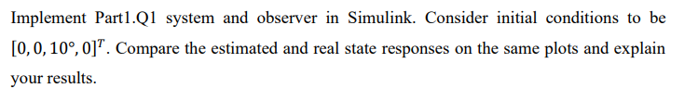

# Solution

The system is implemented in MATLAB Simulink and the results are plotted in this part. Furthermore, feedback controller from previous homework is also used to stabilized the results.

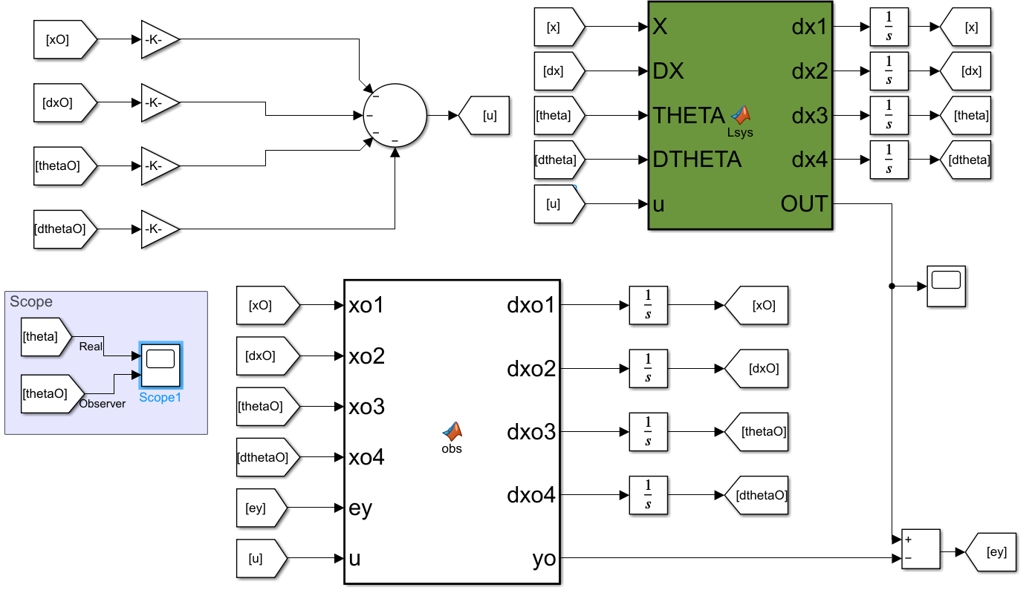

It can be observed that the observer can estimated the results after a couple of time.

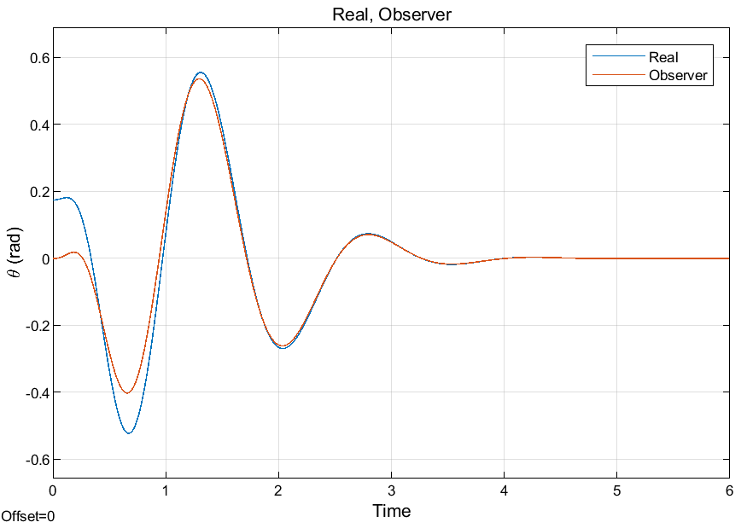

# Problem 2.2 Description

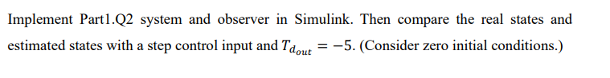

# Solution

The system has been implemented in MATLAB Simulink and the error has been evaluated. The step has been given to the system as an input.

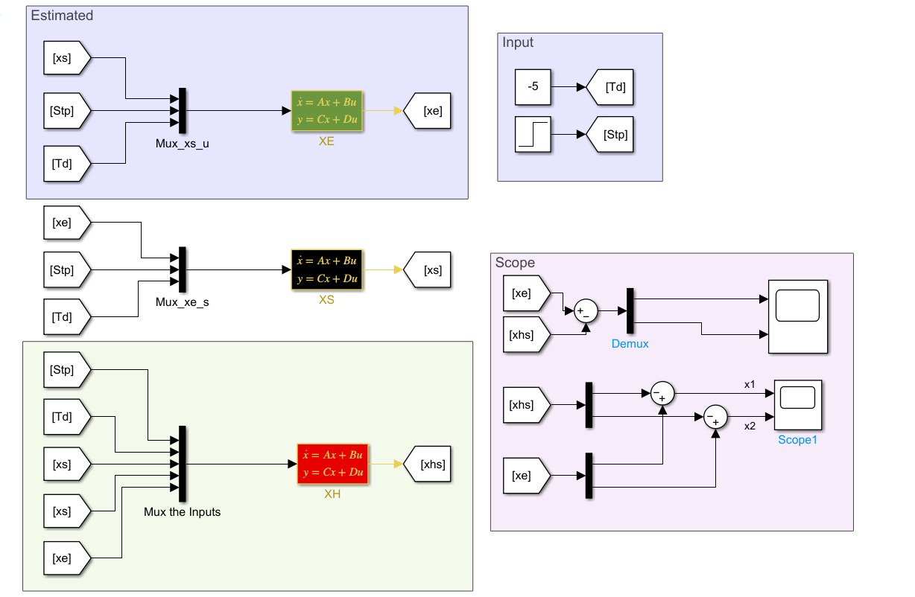

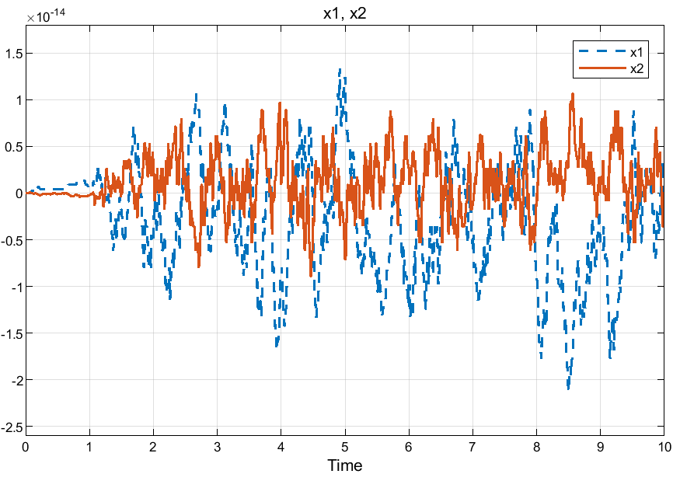

# Problem 2.3 Description

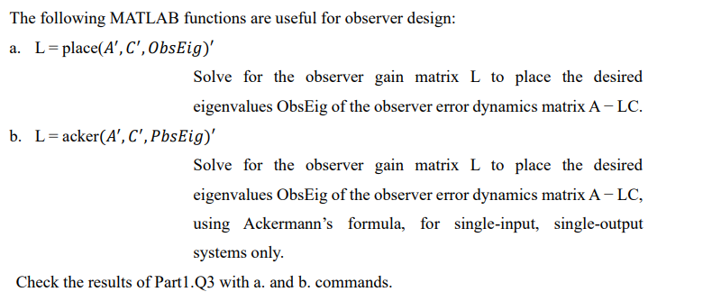

# Solution

Codes have been written in MATLAB, and the results are as follows,

|  |
| --- |
| clc  clear  close all  A=[0 1 0;0 0 1;-6 -11 -6];  C=[1 0 0];  ObsEig=[-5 -2-3.464i -2+3.464i];  L1=place(A.',C.',ObsEig).'  L2=acker(A.',C.',ObsEig).' |

results,

|  |
| --- |
| L1 =  3.0000  6.9993  -0.9993  L2 =  3.0000  6.9993  -0.9993 |

It can be seen that the results are the same.

# Problem 2.4 Description

Implement Part1.Q4 in MATLAB and check your controller and observer results.

# Solution

In order to check our obtained results, they are implemented in MATLAB Simulink,

For instance, in the case of controllability, setteling time should be estimated near

$$t_{s}=\frac{4}{σ}=\frac{4}{1.50}=2.667 s$$

Step plot is considered, and the settling time is reported here,

$$t_{s}=2.7 s$$

Therefore, it is correctly proposed!

Then, in the case of observer,

$$t_{s}=\frac{4}{σ}=\frac{4}{7.5}=0.53 s$$

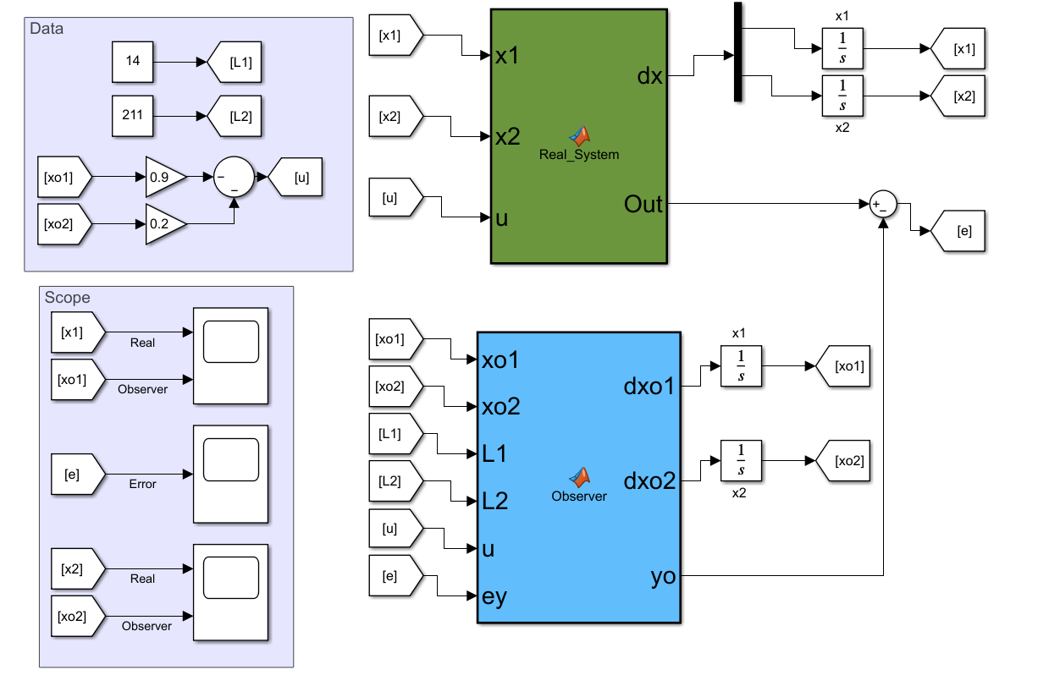

The initial condition is equal to $1$, for the first state, and the results are as follows,





Figure The states response due to an initial condition.